|  |
| --- |
| C:\Users\CHAYAPATHI-CPN\Desktop\download.png  **Department of Information Science and Engineering** |
| **Acharya Institute of Technology** |
| Acharya Dr. Sarvepalli Radhakrishnan Road, Bangalore-560107 |

|  |  |  |  |  |  |
| --- | --- | --- | --- | --- | --- |
| **WEEKLY PROGRESS REPORT** | | | | | |
| **Batch No** | | **Batch-5** | | | |
| **Guide** | |  | | | |
| **Project Title** | | **IOT based wireless smart board** | | | |
| **Progress Report No** | | **3** | | | |
| **Date of Submission** | | **16 Nov 2018** | | | |
| **Date** | | **From: 02 Nov 2018** | | | **To:16 Nov 2018** |
|  | | | | | |
| **Sl. No.** | **Student Name** | | **USN** | **Signature with date** | |
| **1** | Pravesh Kasaundhan | | **1AY15IS072** |  | |
| **2** |  | |  |  | |
| **3** |  | |  |  | |
| **4** |  | |  |  | |
|  | | | | | |
|  | | | | | |

Progress:

**Raspberry Pi 3 Starter Kit Guide**

### Materials Required

You’ll need a mouse, keyboard, and monitor to begin with. Once configured, the pi can be operated from its own peripherals or another computer connected over the internet.

**As a desktop, these materials are required:**

* Pi 3 Starter kit -or- Pi 3/2 Accessory Kit and your own Pi
* USB Mouse
* USB Keyboard
* HDMI monitor/TV/adapted VGA

**After configuration, ‘headless’ operation over Telnet/SSH requires:**

* Pi 3 Starter kit -or- Pi 3/2 Accessory Kit and your own Pi
* 2nd computer connected via internet
* Telnet/ssh terminal software

## Assembly

The Pi is straight-forward and easy to put together, but in the event that something doesn’t seem right, this section will give you an idea of what it is supposed to look like.

Unbox and gather these components before beginning the assembly

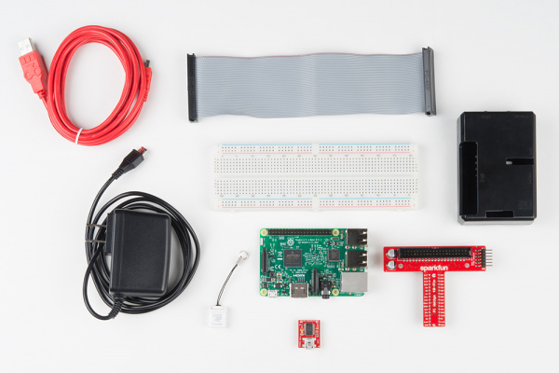

Fig:1.1

1. Snap the Pi into the base of the ‘tin’, then snap the top into place.

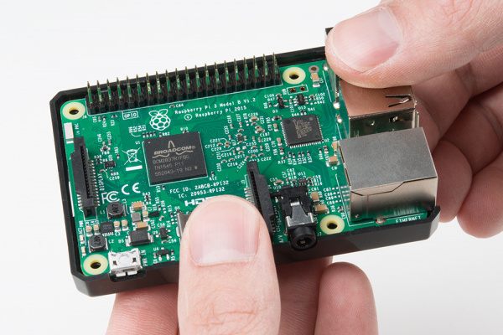

Fig:1.2

1. Fit the Pi into the base of the tin. Make sure the Pi is fully seated. Check that the PCB is evenly recessed about the perimeter.

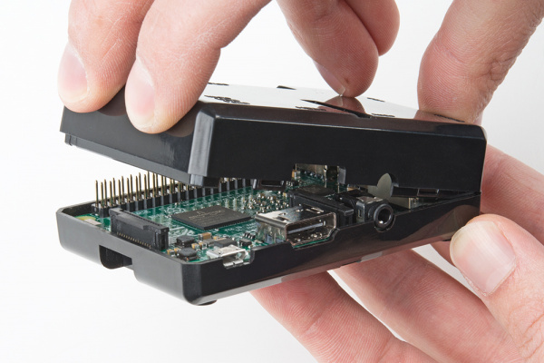

Fig:1.3

1. Click the two halves together and close the lid properly taking care of all the pins that should be properly attached.
2. [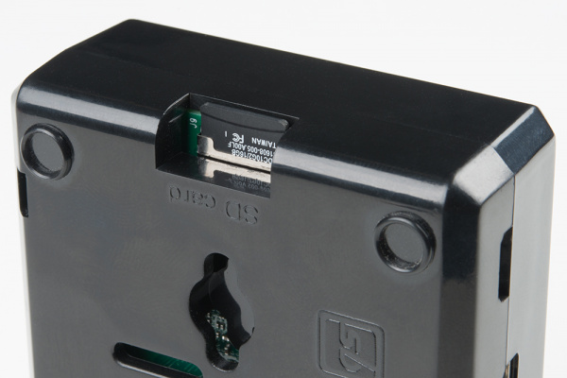](https://cdn.sparkfun.com/assets/learn_tutorials/4/9/6/Raspberry_Pi_3_Hookup_Guide-04.jpg)Add the SD card. While Installing an SD card – make sure the microSD card is flush with the side of the case when inserted properly. The Pi 3 microSD slot doesn’t have a spring as the previous pics did, so if it’s flush with the label outward, it is seated correctly.

Fig:1.4

1. Connect the ribbon cable to the Pi – notice that the pin 1 marking is very subtle. Orient the red stripe on the cable towards the SD card. Alternately, pin 1 can be identified by finding the missing/bevelled corner of the header’s silkscreen on the pi.

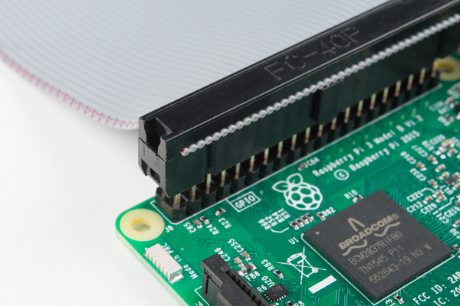

Fig:1.5

1. The pin 1 location and silkscreen are the same between the Pi B+ and Pi B. This image shows a partially inserted ribbon cable without the case in the way. The ribbon cable is oriented with the red “pin 1” marking pointing towards the SD card slot.
2. Attach the ribbon cable to the wedge. Pin 1 is pointing towards the FTDI adapter.

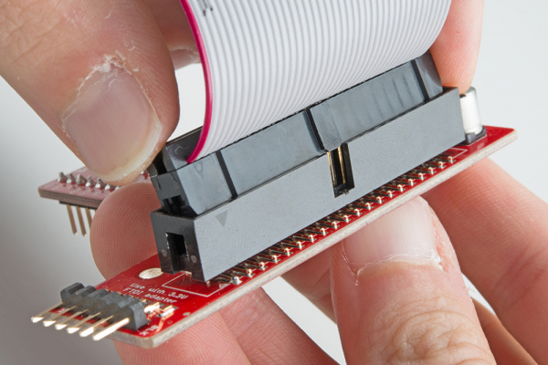

Fig:1.6

1. Socket the end of the ribbon cable into the Wedge. It is keyed, but each end of the cable is different. Make sure the ribbon extends away from the breadboard connection.
2. Socket the Wedge into your breadboard and insert the Wedge into breadboard.

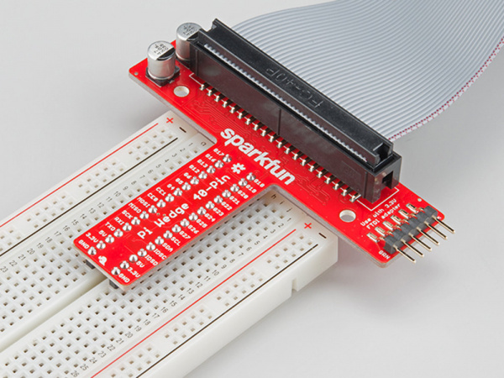

Fig:1.7

1. Attach the FTDI connector matching “GRN” to “GRN” and “BLK” to “BLK” between the boards.

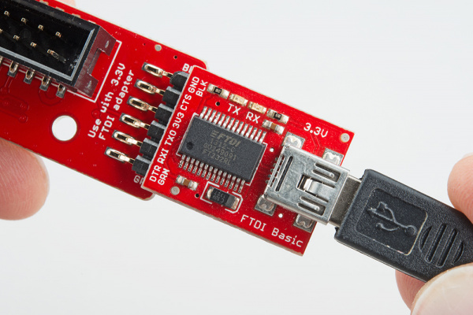

Fig:1.8

1. The FTDI serial adapter is connected matching GRN and BLK connections
2. Attach desired consumer computer equipment.

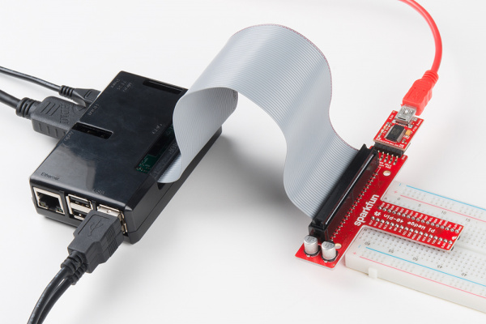

Fig:1.9

1. The fully assembled kit. Additional to the kit, user supplied monitor, mouse, and keyboard are shown. This Pi is now a desktop computer.

Work schedule and expected result for the next week

* We went through the basics of python libraries and we are planning to learn the implementation of these libraries for our project.

## Reading Inputs and Toggling the LEDs.

References:

* www.raspbian.org
* www.python.org
* [www.raspberrypi.org](http://www.raspberrypi.org)
* [www.dataplicity.com](http://www.dataplicity.com)
* learn.sparkfun.com/tutorials/
* <https://www.youtube.com/watch?v=6E9n71zeETE>
* <https://www.youtube.com/watch?v=9rE_XLX-z60>

Project Guide Project Coordinator HOD-ISE

(Signature With Date) (Signature With Date) (Signature With Date)